Assigment IAM

Step 1: Create a user

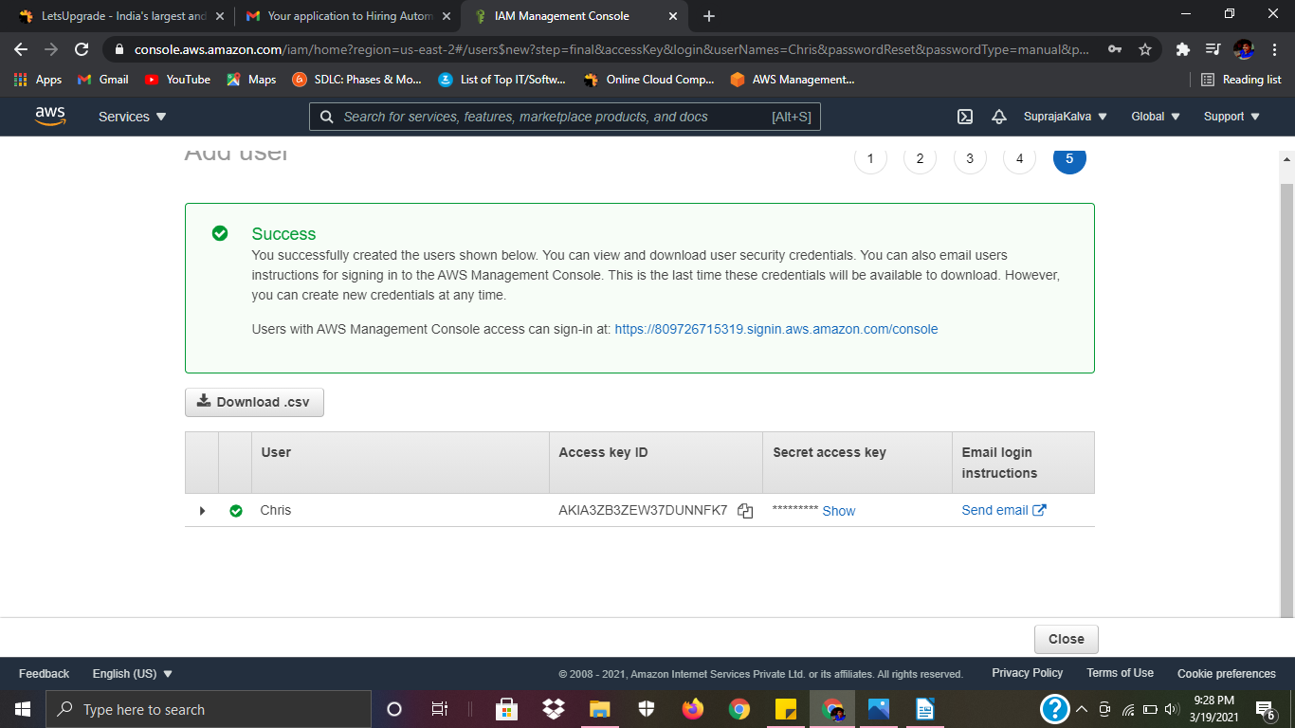
Step 2: Assign Permissions for user

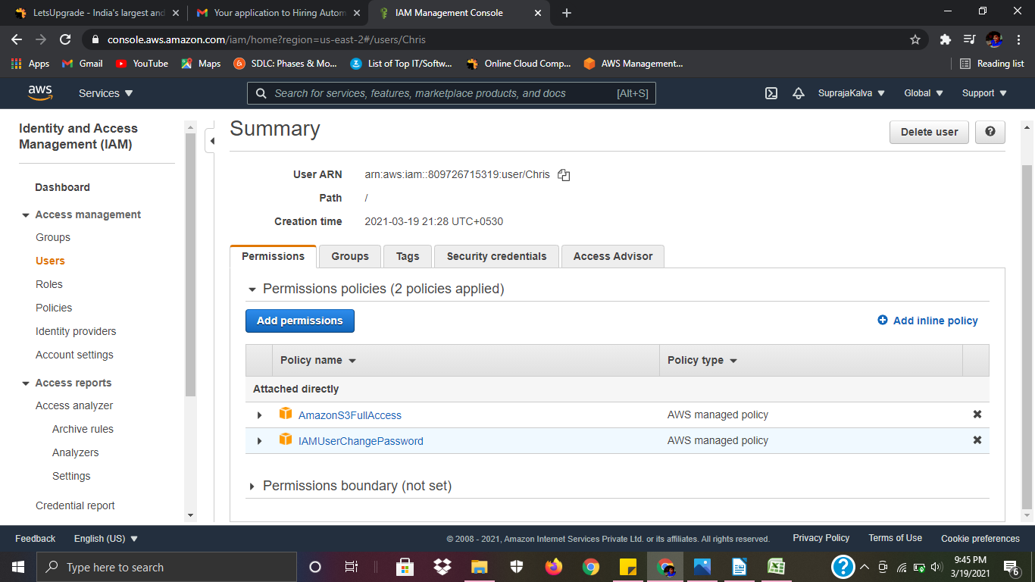

Step 3: Check the permissions, we have full access to S3.

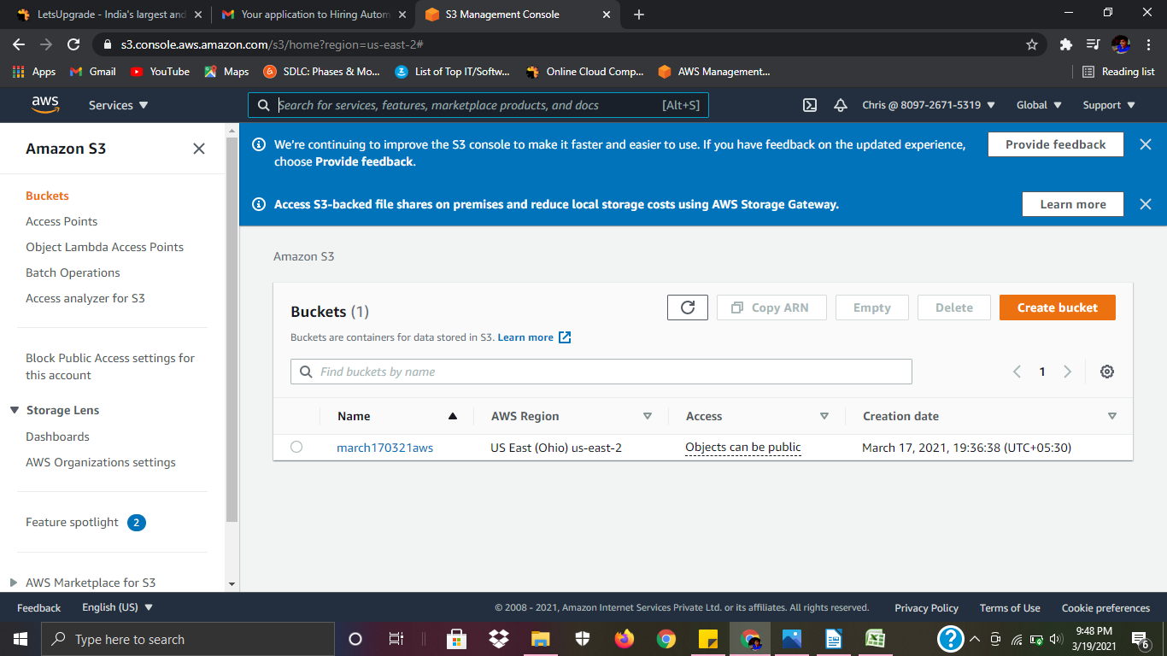
We have no access to EC2 or IAM.

